Basic Questions :

Q1. What are components of a computer ?

Ans: RAM ,CPU, MOTHERBOARD,HARDRIVE(ROM)

Q2. Which CPU are you using in you laptop / mobile / PC ?

Ans: INTEL CORE i7 10th Generation

Q3. What is size of RAM in your PC ?

Ans: 16 GigaByte

Q4. Read Python documentation from

https://docs.python.org/3/tutorial/index.html

Q5. What are different implementations of Python ? Which implementation we are using ?

Ans: CPYTHON, PYPY, IronPython, CLPython, JPython etc. We are using CPython

Q6. Who created python ? in which year ? where ?

Ans: Guido van Rossum created Python in the year 1989 at CWI Netherlands

Q7. What is PVM ?

Ans: PYTHON VIRTUAL MACHINE is the core of the complete Python interpreter which is used to interpret the python compiled byte code into output.

Q8. Python is platform independent or not ? Which platforms python can run ?

Ans: It is Platform Independent means it can run on any Platform/OS. All platforms like MacOS, Linux, Windows etc.

Q9. Why python is platform independent ? What makes it platform independent ?

Ans: This is because it is compiled and interpreted meaning after compilation the code is converted to byte code which can then be run on any machine having python installed.

Q10. WAP to Print "Hello IACSD" and write comment describing author of the program and date created

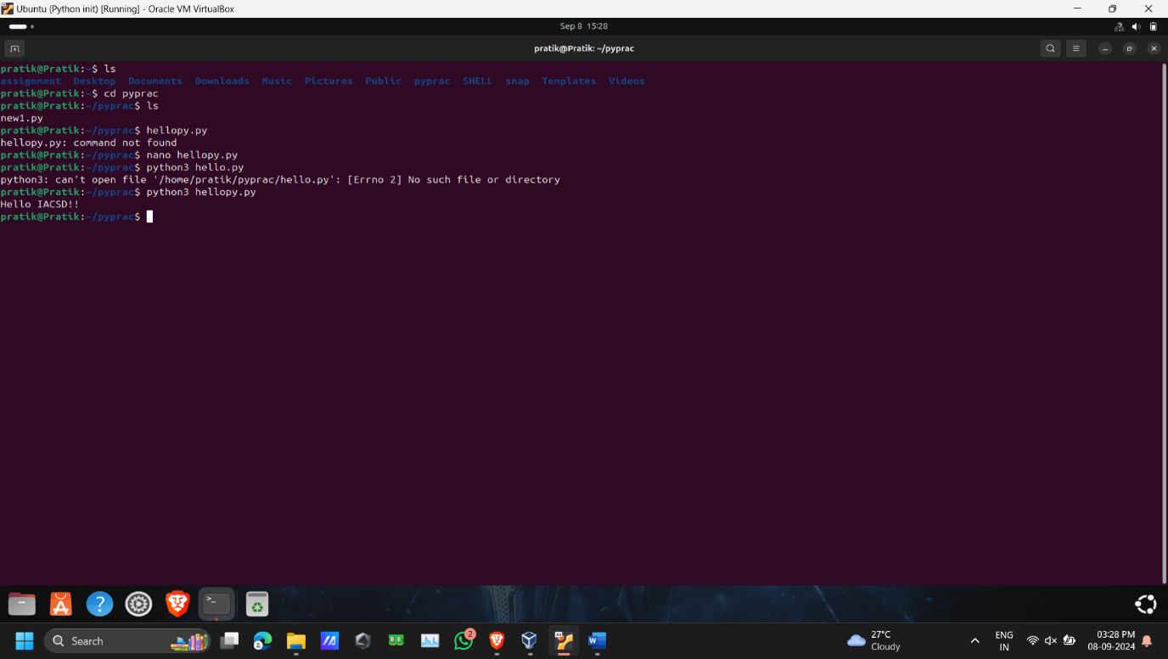

Q11. Find working of various functions (min 7) from math library of python which is provided as standard library.

https://docs.python.org/3/library/math.html

You can also try it yourself.

Ex.

import math

print(math.factorial(4))

print(math.sin(90))

* math.**ceil**(*x*)
* math.**comb**(*n*, *k*)
* math.**copysign**(*x*, *y*)
* math.**fabs**(*x*)
* math.**factorial**(*n*)
* math.**floor**(*x*)
* math.**fmod**(*x*, *y*)
* math.**frexp**(*x*)

Q12. Open VSCode IDE and create a python program (.py file) to print Hello world!. Run the program and check the output on console.

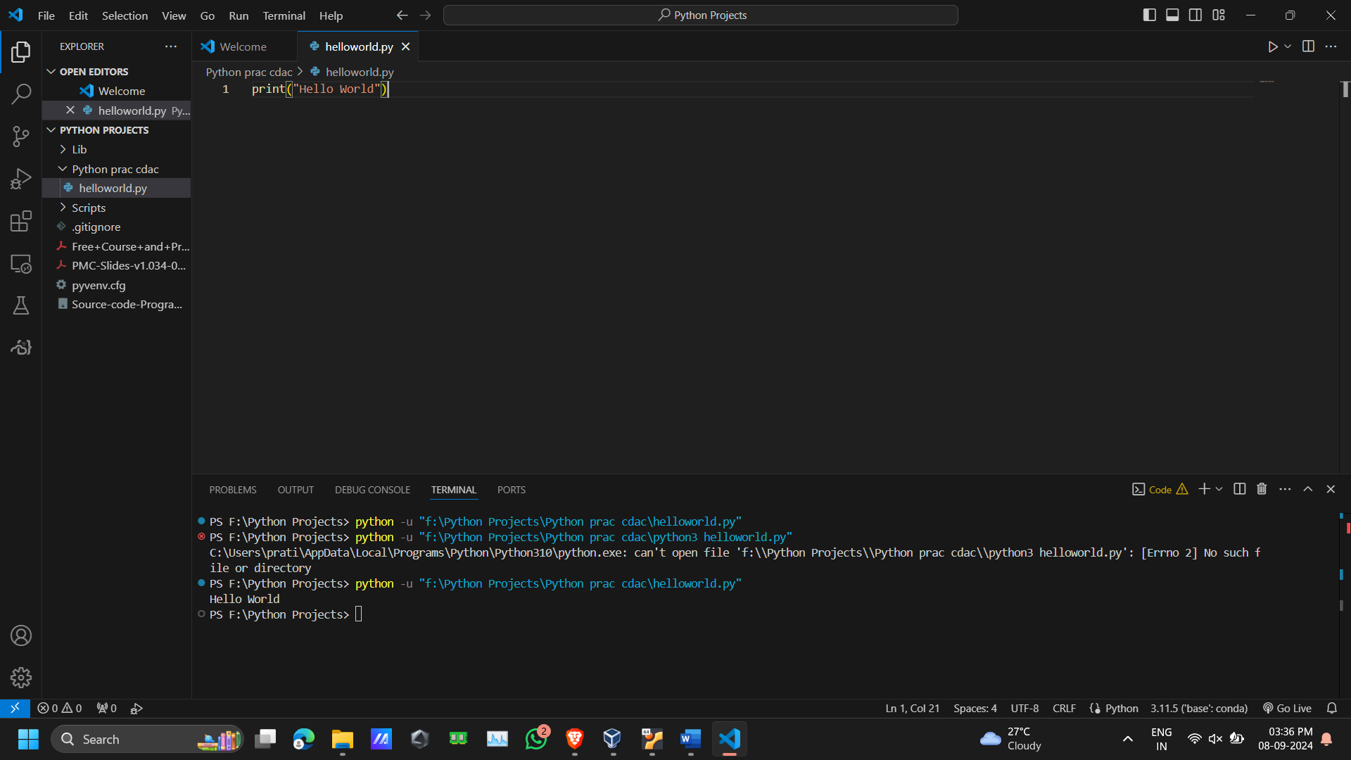

Q13.WAP using VSCode IDE. Import math library and print the gcd, lcm of two numbers.

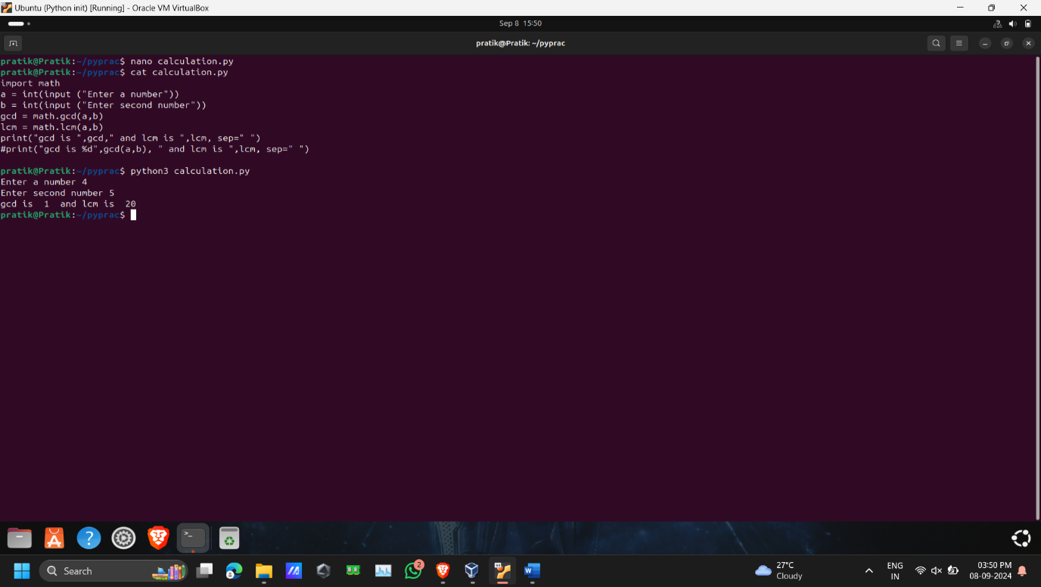

Q14. WAP using VSCode IDE. Use math library. Print number of options you have, when you are given 5 different characters and you need to select 3 of them without repeatitions. (find permutations)

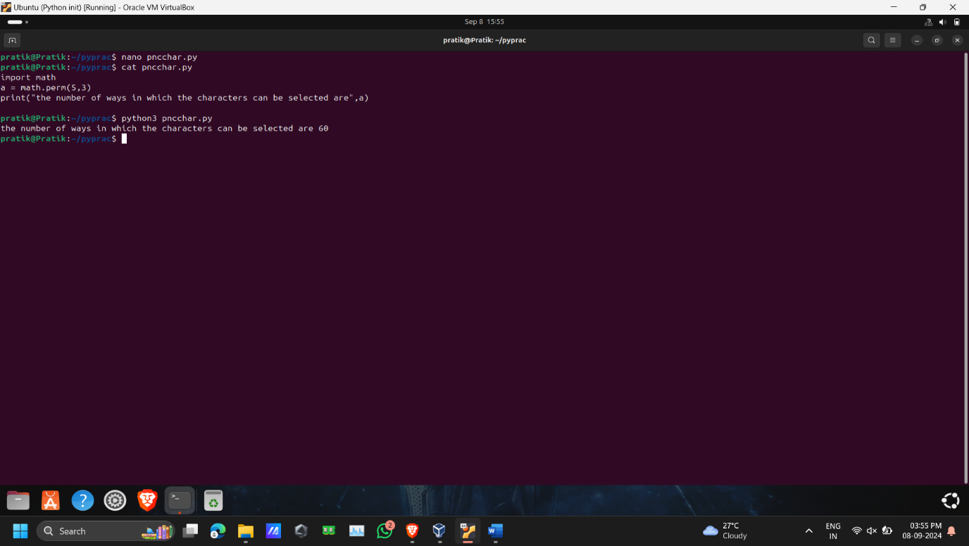

Q15. WAP using VSCode IDE. Use math library. Print number of options you have to select 20 students out of 60 without repeatitions. ( Obviously here order doesn't matter, so find combinations)

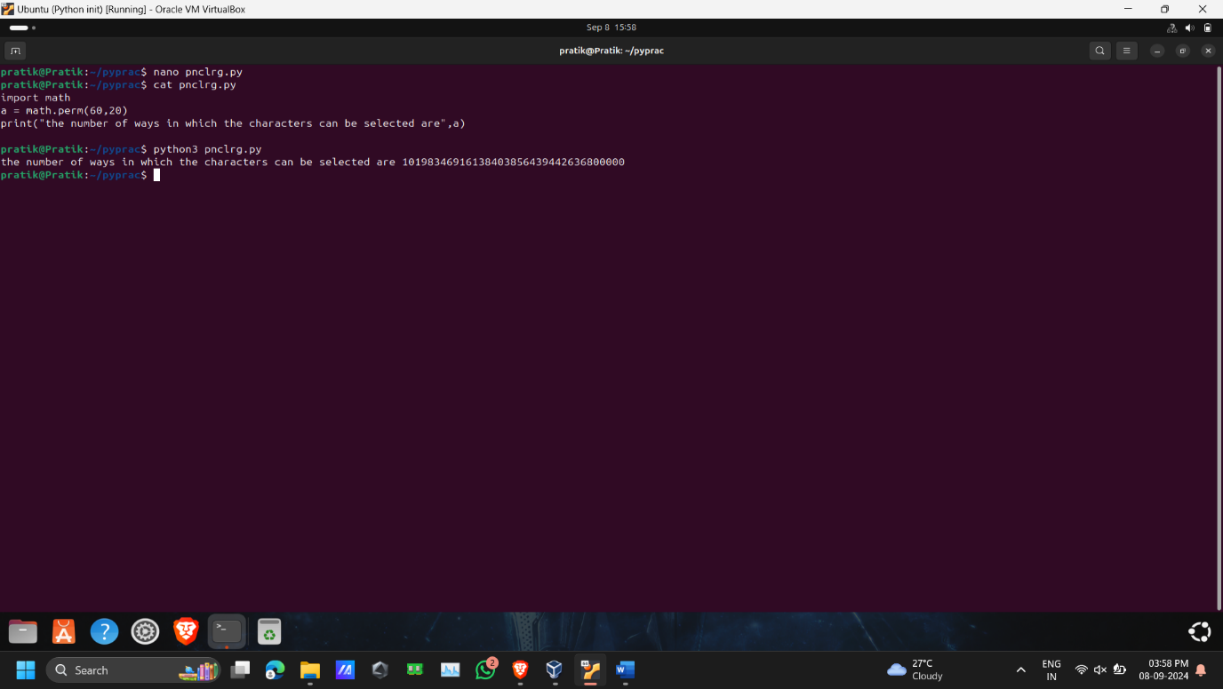

Q16. WAP using VSCode IDE. Use math library. Try to find log of zero. Which error is given ?

Also try to find square root of any negative number. What error is give?

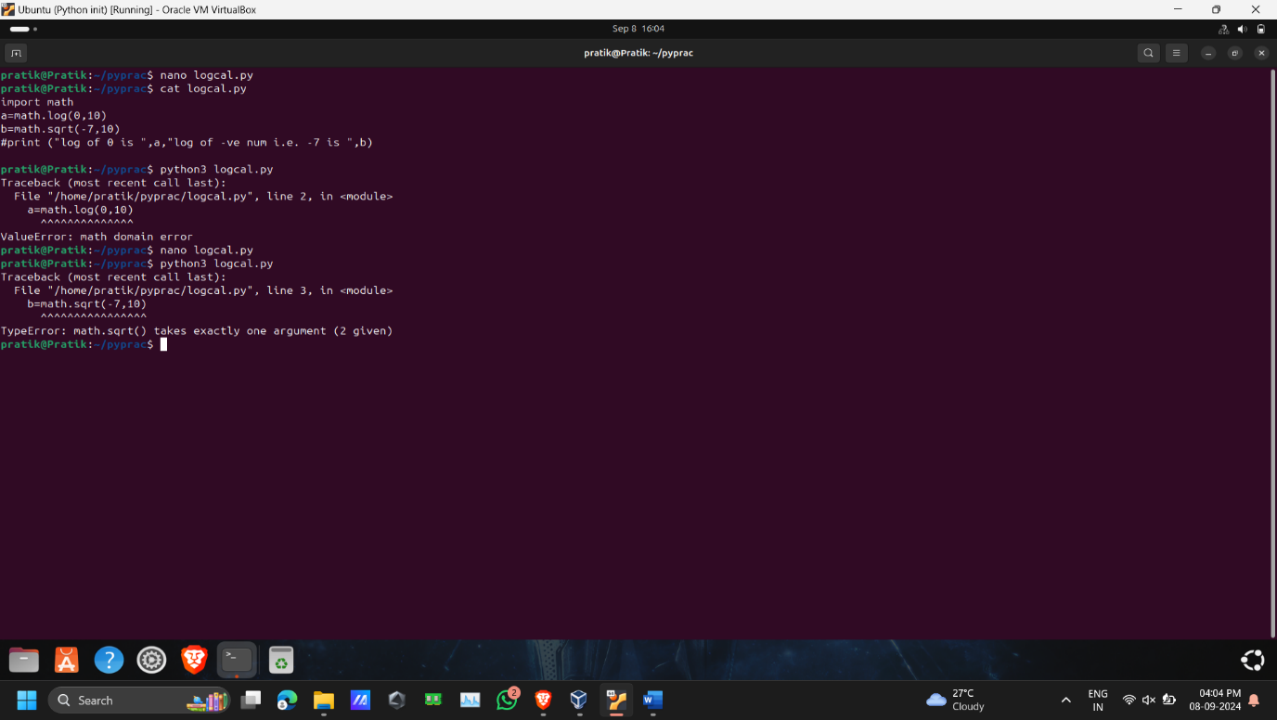

Q17. WAP to create a variable v1 and store any number. Find the square root of that number by using v1 in math.sqrt() function.

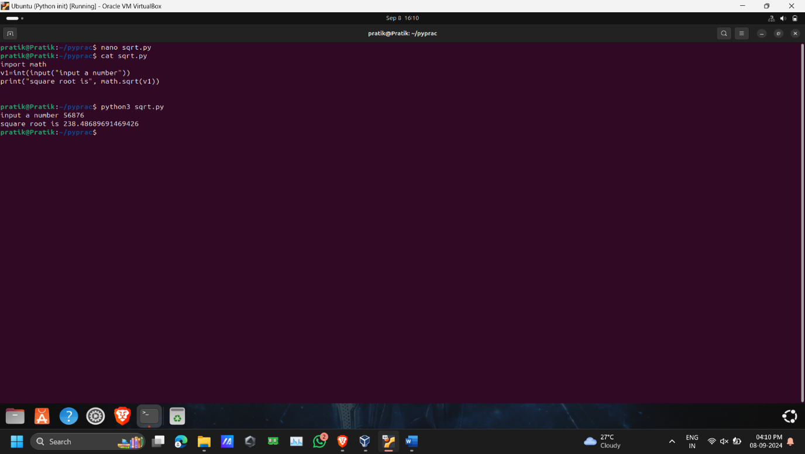Q18. Why python is considered as slow compared to C, C++ ?

Refer : https://stackoverflow.com/questions/3033329/why-are-python-programs-often-slower-than-the-equivalent-program-written-in-c-or

Q19. Check where .pyc files are stored after you run the program for Q15.

Advanced Assignments

Q. What are different extensions supported by python?

What is meaning of .py , .pyc, .pyz, .pyo, .pyd , etc extensions supported by python?

Q. Check what happens if we print math.sqrt without any parnthesis ? What happens if we print math.sqrt() without passing any number to it?

Q. Can we convert .pyc file to python code? how?

Q. What is Global Interpreter Lock (GIL)?

Q. Which language is used to write python interpreter?

Q. What is advantage of garbage collector over manual memory management by the programmer ?

Q. When variable is created what is on stack and what part is on heap ?

Q. What is garbage collector ? How reference counting works ?